
Basic Statistics (Module -3)

Q1) Calculate Skewness, Kurtosis & draw inferences on the following data
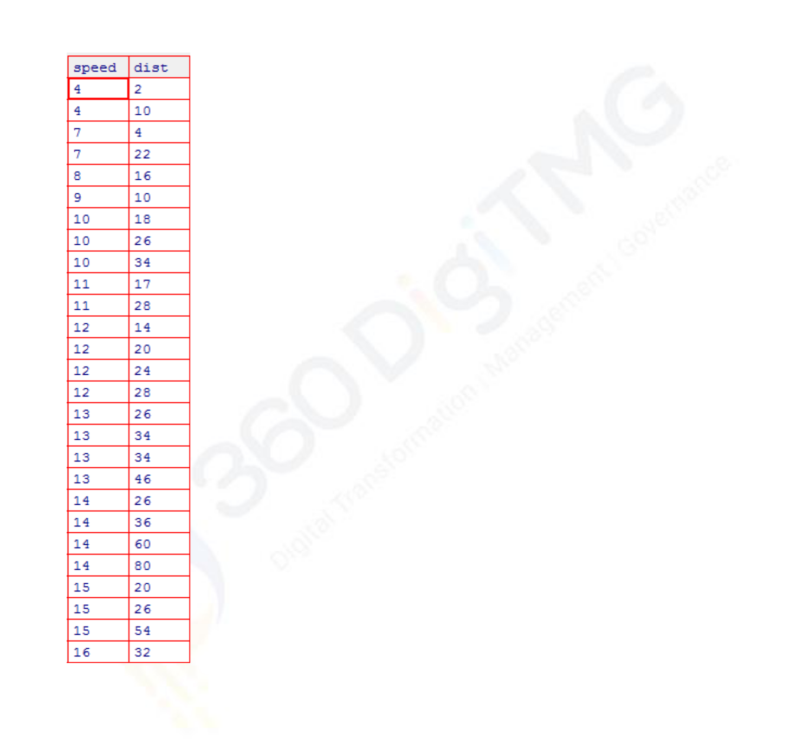

a. Cars speed and distance

© 2013 - 2020 360DigiTMG. All Rights Reserved.
→ Ans 1 .a)
library(e1071)
cars = read.csv(file.choose())
attach(cars)
kurtosis(cars$speed)
skewness(cars$speed)

kurtosis(cars$dist)
skewness(cars$dist)

kurtosis(cars$speed)
[1] -0.6730924
> skewness(cars$speed)
[1] -0.1105533
>
> kurtosis(cars$dist)
[1] 0.1193971
> skewness(cars$dist)
[1] 0.7591268

b. Top Speed (SP) and Weight (WT)
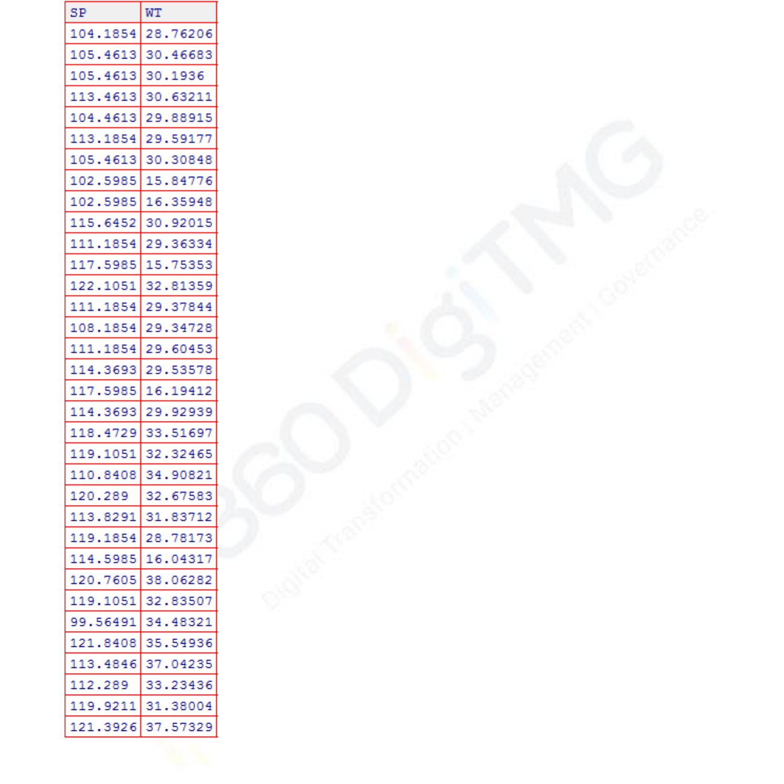

→
Ans 1.b

cars2 = read.csv(file.choose())
kurtosis(cars2$SP)
skewness(cars2$WT)

kurtosis(cars2$SP)
skewness(cars2$WT)

kurtosis(cars2$SP)
[1] 2.583072
> skewness(cars2$WT)
[1] -0.5921721
>
> kurtosis(cars2$SP)
[1] 2.583072
> skewness(cars2$WT)
[1] -0.5921721
>

© 2013 - 2020 360DigiTMG. All Rights Reserved.
Q2) Draw inferences about the following boxplot & histogram
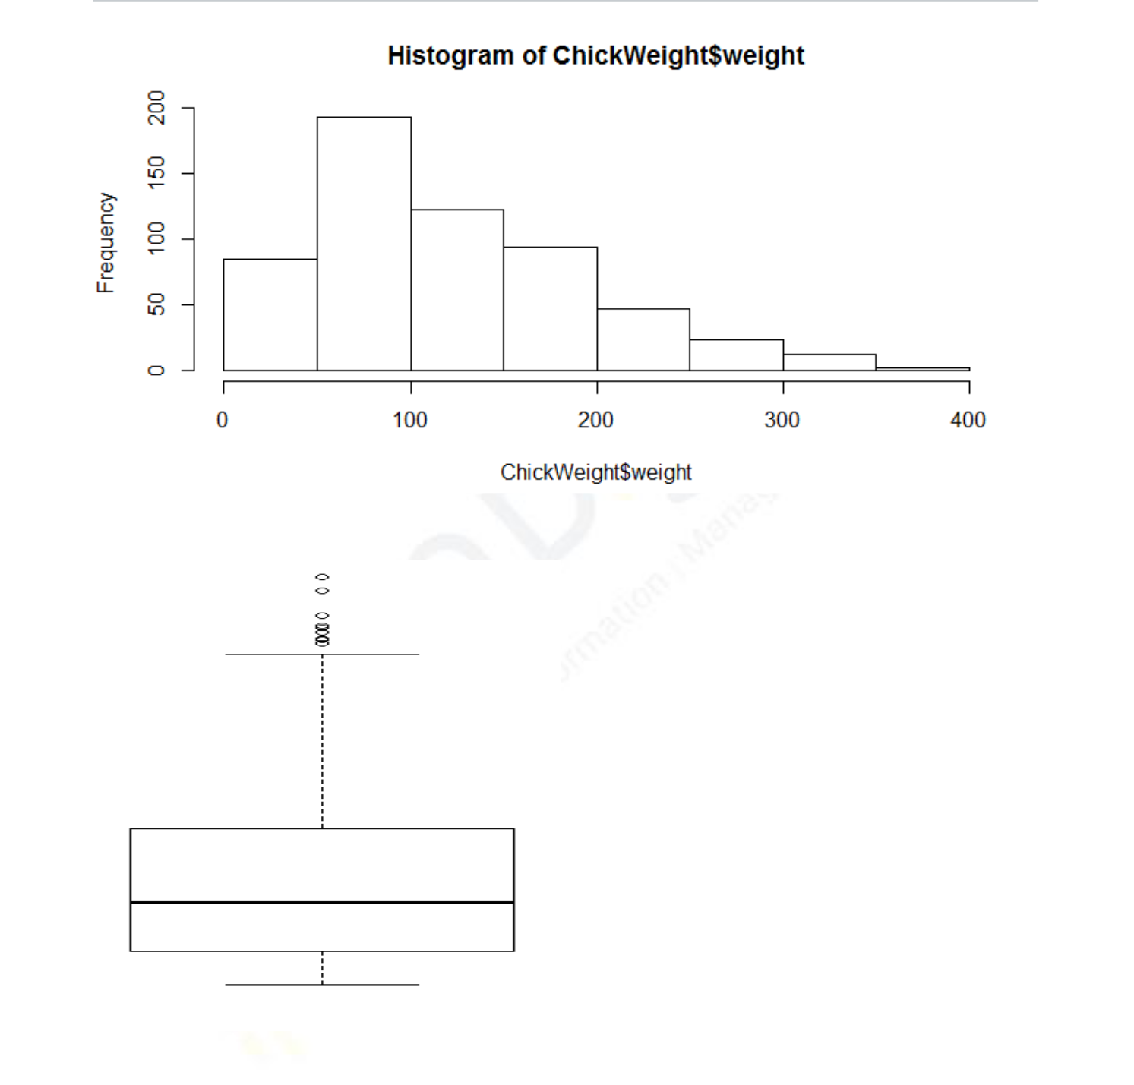

- Ans 2) 2.a
Histogram. It is right skewed then its Positive. As the right side is longer than left side and importantly MEAN IS greater than
MEDIAN. As the tail is inclined towards right side.

- 2.b
The boxplot of a weight which is skewed to the right. The top whisker is much longer than the bottom whisker and the line is gravitating towards the bottom of the box.
We can inference that it is right skewed and positive side.
Its Upper whisker is MAX value greatest value excluding outliers
Skewed data show a lopsided boxplot, where the median cuts the box into two unequal pieces. If the longer part of the box is to the right (or above) the median, the data is said to be skewed right.

Q3) Suppose we want to estimate the average weight of an adult male in Mexico. We draw a random sample of 2,000 men from a population of 3,000,000 men and weigh them. We find that the average person in our sample weighs 200 pounds, and the standard deviation of the sample is 30 pounds. Calculate 94%,98%,96% confidence interval?

© 2013 - 2020 360DigiTMG. All Rights Reserved
[1] 25.52941

Q4) Below are the scores obtained by a student in tests

34,36,36,38,38,39,39,40,40,41,41,41,41,42,42,45,49,56
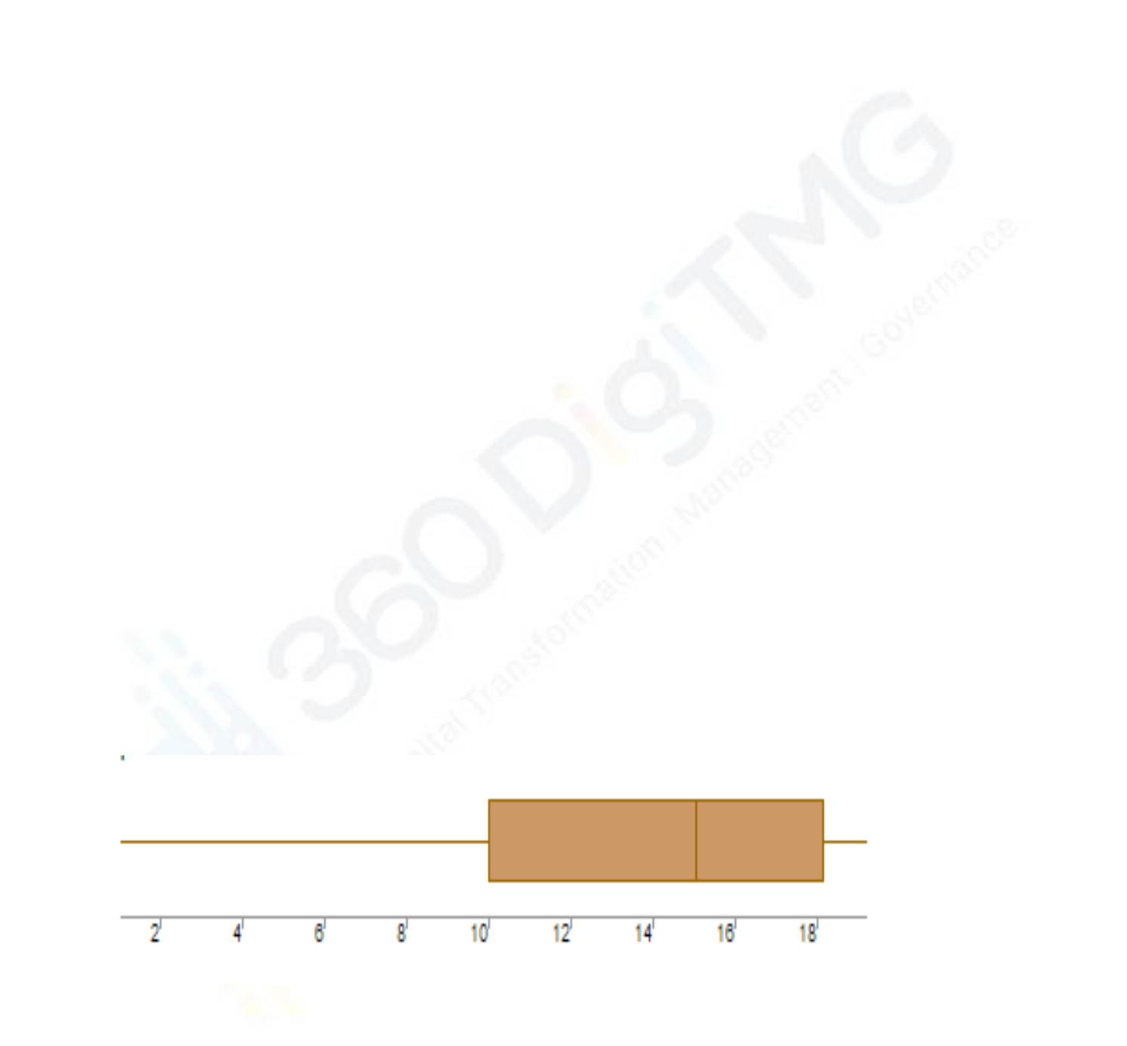
- Find mean, median, variance, standard deviation.
→
x <- c(34,36,36,38,38,39,39,40,40,41,41,41,41,42,42,45,49,56)
mean(x)
median(x)
sd(x)
range(x)
var(x)

mean(x)
[1] 41
> median(x)
[1] 40.5
> sd(x)
[1] 5.052664
> range(x)
[1] 34 56
> var(x)

- What can we say about the student marks?

→
Normally distributed data as the median in the above dataset is actually 41 and on the either side the data is not having any outliers and no data seems to have drastic changes.

Q5) What is the nature of skewness when mean, median of data are equal?

If median == mode. then we say the distribution is symmetric and has 0 skewness. i.e. Its normally distributed.

Q6) What is the nature of skewness when mean > median?

- If the mean is greater than the mode, the distribution is positively skewed *(right skewed ) .

Q7) What is the nature of skewness when median > mean?

- If the mean is less than the median, the distribution is negatively skewed.

Q8) What does positive kurtosis value indicates for a data?

Positive kurtosis indicates thick tails (fat tails ) than a normal distribution. .It indicates high peak.
+ve kurtosis is also called LEPTOKURTIC . In extreme cases it indicates more of the values are located in the tails of the distribution rather than around the mean.

Q9) What does negative kurtosis value indicates for a data?

Negative values of kurtosis indicate that a distribution is flat and has thin tails. Platykurtic distributions have negative kurtosis values.
A platykurtic distribution is flatter (less peaked) when compared with the normal distribution, with fewer values in its shorter (i.e. lighter and thinner) tails.

Q10) Answer the below questions using the below boxplot visualization.

In the above boxplot where the median cuts the box into two unequal pieces. If the longer part of the box is to the left, the median, the data is said to be skewed left. It means its negative skewed. And mean is mostly less than mode, median.

What can we say about the distribution of the data?

Referring to the dataset for marks:

x <- c(34,36,36,38,38,39,39,40,40,41,41,41,41,42,42,45,49,56)
hist(x)

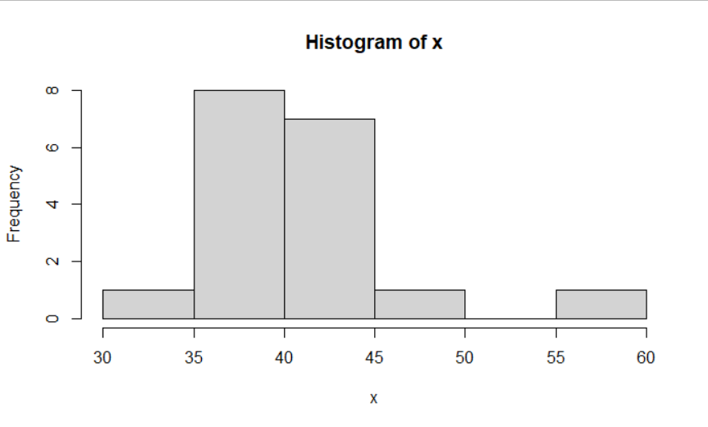

Huge proportion of data is concentrated on the left side and then has long right tail . inclining A histogram is right skewed if the peak of the histogram veers to the left. Therefore, the histogram’s tail has a positive skew to the right...

What is nature of skewness of the data?

→ The Skewness of the dataset of marks is positive skew to the right. Mean is greater than mode, median and skewness is greater than 0.

What will be the IQR of the data (approximately)?

→ x <- c(34,36,36,38,38,39,39,40,40,41,41,41,41,42,42,45,49,56)
boxplot(x, horizontal = TRUE)

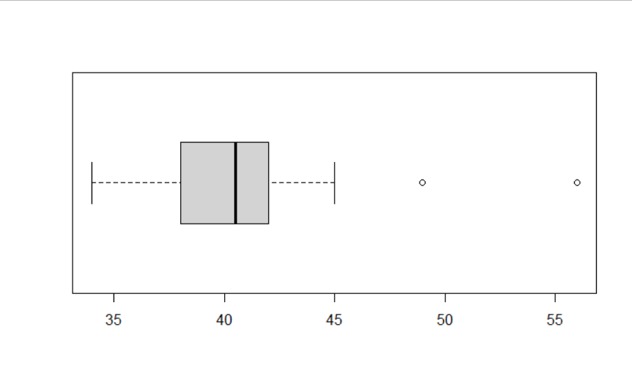

By looking at the median , it is most likely positive skewed as it is influenced by outliers and after taking the skewness in R.

x <- c(34,36,36,38,38,39,39,40,40,41,41,41,41,42,42,45,49,56)
skewness(x)
skewness(x)
[1] 1.416114 . skewness>0 .hence its is right (+ve) skewed.

To find the IQR of the data .
1) Find the median

x <- c((34,36,36,38,38,39,39,40,40,)|(41,41,41,41,42,42,45,49,56))

median(x)
[1] 40.5

2.) Divide the given dataset into 2 halves and find median among them.

Q1 <- c(34,36,36,38,38,39,39,40,40)
median(Q1)

median(Q1)
[1] 38

Q2 <- c(41,41,41,41,42,42,45,49,56)
> median(Q2)
[1] 42

Subtract Q1 from Q3.
Ignoring -ve
38-42 ==== 4

The IQR is 4 ~

© 2013 - 2020 360DigiTMG. All Rights Reserved.

Q11) Comment on the below Boxplot visualizations?
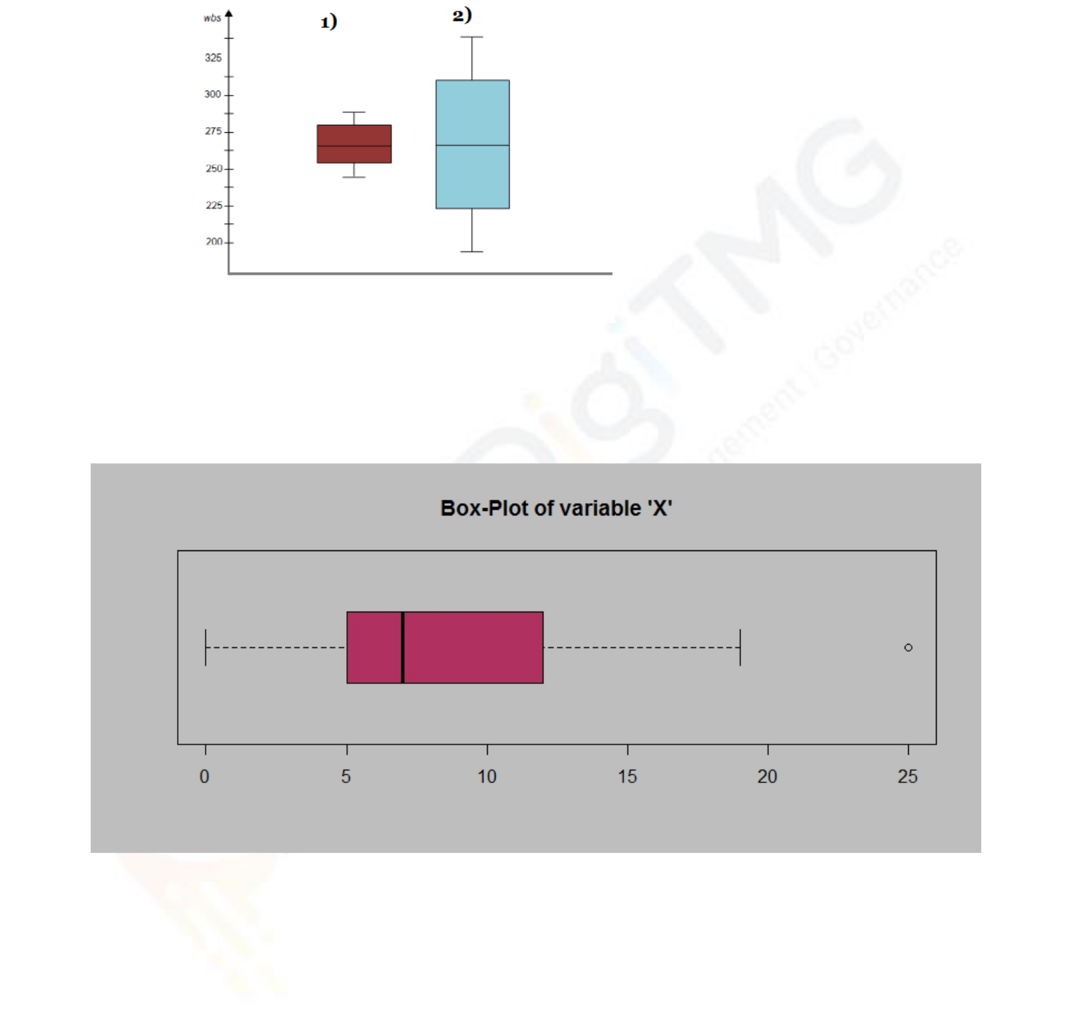

Draw an Inference from the distribution of data for Boxplot 1 with respect Boxplot 2

Q12)

Answer the following three questions based on the boxplot above.

- What is inter-quartile range of this dataset? (please approximate the numbers) In one line, explain what this value implies.

- What can we say about the skewness of this dataset?

- If it was found that the data point with the value 25 is actually 2.5, how would the new boxplot be affected?

© 2013 - 2020 360DigiTMG. All Rights Reserved.

Ans 11)
Compare the interquartile ranges (that is, the box lengths), to examine how the data is dispersed between each sample. The longer the box the more dispersed the data. The smaller the less dispersed the data.

So from the above two figures , it looks like the boxplot 1 is symmetric almost .that is normally distributed and little chance of being almost similar to the boxplot 2 . Both look symmetric in their own .

But when comparing them it can be observed that median of both boxplots are almost at the same line and if we draw a line through both the median then both are actually having same median , even if the data set might be different or used different variables.

Ans 12)
  - IQR = q1 -q3
So q1 =(5 ,7.5) ~ mean = 6.25
Q3= ( 7.6 ,10) ~ mean =8.8
IQ3 =Q1 -Q3 == 2.54

ii)
Skewness of the data from the above boxplot is Right Skewed as the right whisker is slightly more than left whisker . so that means the mean is greater than mode ,median most likely and skewness is > 0 .(positive skewed)

- Outlier analysis there are many techniques of which to use (3r Technique to rectify or retain) it falsely accepted as outlier and it was actually not so it’s a False Positive.

Q13)
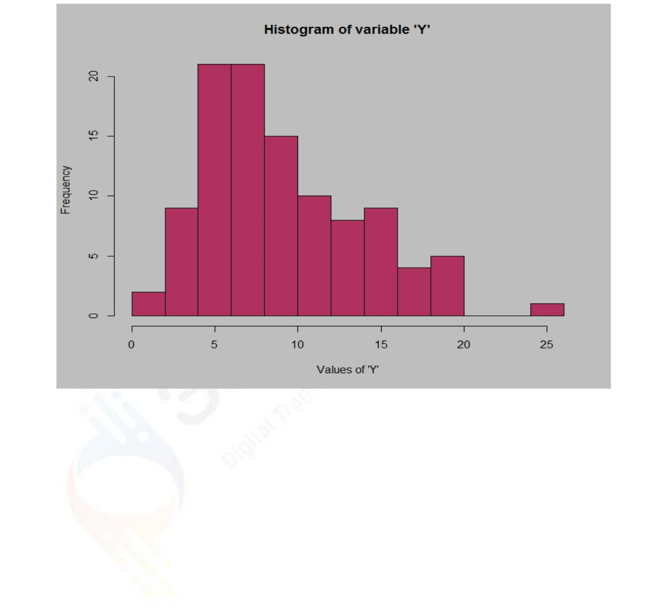

Answer the following three questions based on the histogram above.

- Where would the mode of this dataset lie?

- Comment on the skewness of the dataset.

- Suppose that the above histogram and the boxplot in question 2 are plotted for the same dataset. Explain how these graphs complement each other in providing information about any dataset.

Ans 13 )
- Mode is the peak of the histogram since we have 2 bins having same frequency above 20 ( 22~) ,we can assume the Mode to be 4.5 -7.
- Right Skewed as it has long tails on the right side and skewness is greater than 0 . mean in this case will be greater than median or mode.
- The Skewness of the both histogram above and the boxplot in Q2 are both positive skewed based on the diagrams (Right skewed) and both must have mean > median ,mode.

© 2013 - 2020 360DigiTMG. All Rights Reserved

Hints:

1. Business Problem


1.1. Objective

1.2. Constraints (if any)

- For each assignment the solution should be submitted in the below format

- Research and Perform all possible steps for obtaining solution

- For Basic Statistics explanation of the solutions should be documented in black and white along with the codes.

One must follow these guidelines as well:

4.1. Be thorough with the concepts of Probability, Central Limit Theorem and Perform the calculation stepwise

4.2. For True/False Questions, explanation is must.

4.3. R & Python code for Univariate Analysis (histogram, box plot, bar plots etc.) for data distribution to be attached

- All the codes (executable programs) should execute without errors

© 2013 - 2020 360DigiTMG. All Rights Reserved.

